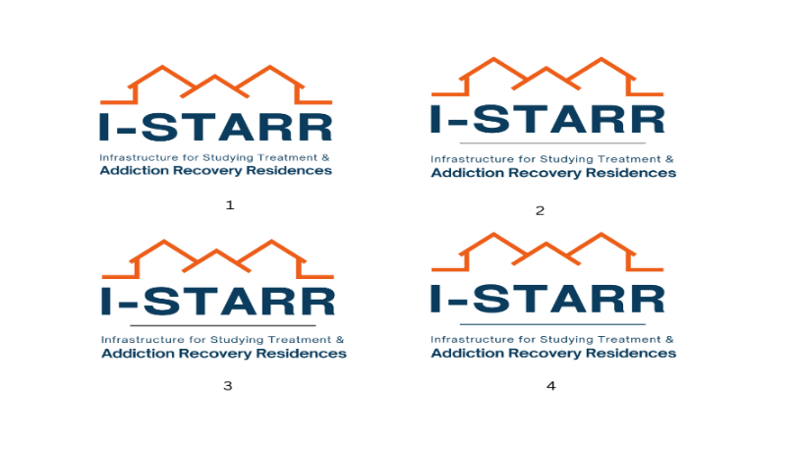

**Infrastructure for Studying Treatment and Addiction Recovery Residences (I-STARR)**

**Request for Applications (RFA) for Pilot Studies**

The I-STARR Pilots program is requesting applications for exciting, novel research advancing the evidence base on recovery housing for people treated with medications for an opioid use disorder (MOUD). The program offers funding, training, and mentorship for investigators new to recovery housing research to conduct small research projects in this general area.  The program intends to launch competitive NIH R-mechanism proposals, and will fund only pilot studies seeking to provide preliminary data and experiences supporting such a proposal.  The parent I-STARR project is funded by the National Institute on Drug Abuse (R24DA051974).

**THE AWARD**

* Funding is offered for up to $50,000 total (direct and indirect) costs per award
* Most studies will be one year in duration
* Up to 2 projects will be awarded per year
* At least 5 pilot studies will be awarded across 2023-2025

**RESEARCH AREAS OF INTEREST**

Pilot studies may focus on diverse topics related to recovery housing for people treated with MOUD.  Examples of studies of particular interest are studies examining:

1. Prevalence of accessing recovery housing for people treated with MOUD and gaps in utilization
2. Barriers to, and facilitators of, accessing recovery housing among people treated with MOUD
3. Outcomes associated with accessing recovery housing for people treated with MOUD and factors affecting such outcomes (such as supportive social networks)
4. Factors associated with MOUD adherence among recovery housing residents

Strategies/interventions for overcoming barriers to supporting residents treated with MOUD

1. Disparities related to accessing and benefiting from recovery residences among people treated with MOUD

**ELEGIBILITY**

* Proposed projects must address the role of recovery housing in supporting persons who are in or seeking recovery from an opioid use disorder and who are or have been maintained on medications for opioid use disorder (MOUD).
* Applicants must meet NIH criteria as an Early Stage Investigator (ESI; investigator completed the terminal research degree or post-graduate clinical training within the past 10 years) or a New Investigator (NI; investigator has not competed successfully for an R01 award); those who do not meet this criteria may still apply if they have not competed successfully for NIH research funding pertaining to recovery housing.
* Applicants may be faculty members, research scientists, post-doctoral research scholars, or graduate students from any academic, healthcare, or research institution in the United States.
* Applicants must designate an I-STARR Investigator who has agreed to be mentor for the proposed project (see <https://istarr.arg.org/>). **Applicants are required to contact the proposed mentor prior to submitting to obtain approval for the submission.**
* Applicants must document how pilot data will be used to launch a successful NIH R-mechanism grant.
* Applications must specify how findings will be disseminated (e.g., via conference presentations and published papers) and how data and findings will be shared in compliance with the HEAL initiative (see <https://heal.nih.gov/data/public-access-data>).

**SPECIAL ELEGIBILITY CONSIDERATIONS**

We especially encourage applicants with the following backgrounds:

* Investigators belonging to populations under-represented in the U.S. research enterprise (see <https://grants.nih.gov/grants/guide/notice-files/NOT-OD-20-031.html>), including:
  + Individuals from under-represented racial/ethnic groups (i.e., Black/African American, Latinx/Hispanic, American Indian/Alaska Native, and Native Hawaiian/Other Pacific Islander people)
  + Individuals with disabilities, defined as those with a physical or mental health impairment
  + Individuals from disadvantaged backgrounds
* Investigators who have lived experience with substance use recovery

**PROCESS**

**Letter of Intent (LOI)**

* Those who meet eligibility criteria must first submit an LOI using the LOI template (attached).
* LOIs will undergo a competitive review process to determine if a full application can be invited; invitation to submit a full application does not guarantee funding.
* Applicants will be notified via email when a decision is made regarding the full application.

**Full Application (By Invitation Only)**

* Those whose LOIs have been approved will be invited to submit a full proposal using a template (to be provided) and including the following core components:

* + Study title and investigator information
  + Applicant’s NIH biosketch
  + Structured abstract (700 words max)
  + Project narrative/public health relevance statement (125 words max)
  + Detailed and clear project proposal (3 pages max not including components below)
  + References (no limit)
  + Statement on Human Subjects/IRB (1 page max)
  + Detailed budget spreadsheet and budget justification (1 page max)
  + Timeline of proposed project activities, including specific products (e.g., presentations, manuscripts) (figure + 500 words max)
  + Oversight and mentorship plan including a description of how progress will be reported and nature and frequency of I-STARR mentorship meetings (200 words max)
  + NIH HEAL Compliant Data Management and Sharing Plan (200 words max)
* Applications should be single-spaced and use 11-point font and .5” margins.
* Applicants will be notified via email when a funding decision is made.

**REVISED KEY DATES FOR 2024-25 CYCLE**

**Jan. 16, 2024 Letters of Intent (LOIs) due**

**Jan. 30, 2025           Select LOIs approved for full applications**

**Apr. 24, 2025      Full applications due**

**May 22, 2025 Funding decisions delivered**

**CONTACTS**

**For administrative questions and to submit application materials, please contact:**

Ms. Kwinoja Kapiteni  
I-STARR Project Coordinator

[kkapiteni@arg.org](mailto:kkapiteni@arg.org)

**For scientific questions, please contact:**

Dr. Carmen Masson

I-STARR MPI

[carmen.masson@ucsf.edu](mailto:carmen.masson@ucsf.edu)

For more, see https://istarr.arg.org/pilot-studies/